Disease dynamics

# Objectives

* Understand R0 and theeffect of vaccination on disease spread
* Understand phase portraits of disease and how they relate to time series
* Understand the herd immunity concept, the epidemic threshold, and how the initial conditions may affect the course of an epidemic

# Before the lab

* Review the lecture material on disease spread
* Read the reading, paying particular attention to phase portraits

Infectious diseases spread when infected individuals contact or come near to susceptible individuals. Some diseases are easier to catch – if they are airborne and survive well outside the body, for example.

To understand and predict how any disease will spread in a population, epidemiologists calculate R0, the expected number of new infections per existing infection in a completely susceptible population. For example, if R0 is 4, we expect 4 new infections from each infection – it will spread quite rapidly at first, then a little more slowly, until just about everyone has been infected.

*Optional self-check question 1:* *What happens if R0 < 1?*

The scenario above assumes that the entire population starts off susceptible, but what if some individuals are immune to the infection because of genotype, acquired immunity, or vaccination? Transmission to immune individuals reduces the chance that the disease will spread. For example, if R0 is 4 but half of the contacts are immune, it can spread at only half the rate it would spread in a completely susceptible population, i.e., there would be 2 new infections per old infection. (That’s still a pretty good rate of spread.)

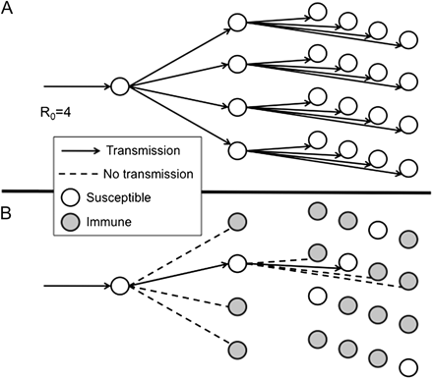

Fig. 1. Diagram illustrating transmission of an infection with a basic reproduction number R0 = 4. (A) Transmission over 3 generations after introduction into a totally susceptible population (1 case would lead to 4 cases and then to 16 cases). (B) Expected transmissions if (R0 − 1)/R0 = 1 − 1/R0 = ¾ of the population is immune. Under this circumstance, all but 1 of the contacts for each case is immune, and so each case leads to only 1 successful transmission of the infection. This implies constant incidence over time. If a greater proportion are immune, then incidence will decline. On this basis, (R0 − 1)/R0 is known as the “herd immunity threshold.” From Fine et al. (2011).

Consider Fig. 1. Part A shows R0 = 4 and all of the population susceptible. Part B shows what happens if ¾ of the population is immune. With this level of immunity, the fraction infected remains constant, and if more of the population is immune, the disease will decrease. The basic principle is that a disease will not take off into an epidemic if the population of susceptible individuals is small. That could be because they have become immune, have died, or have been vaccinated.

The **herd immunity** threshold is thus 1-1/R0. It is the fraction of the population that must be immune in order to stop the disease from spreading.

*Optional self-check 2: If R0 =6, what is the herd immunity threshold (i.e. what fraction needs to be vaccinated to stop an epidemic)?*

If we know R0, we can apply these ideas to determine what fraction of a population we need to vaccinate to prevent a disease from gaining a foothold in that population. But what if we don’t know R0? In that case, we can examine a mathematical model of disease spread, using parameters that are easier to measure. We compartmentalize the population into: **S**usceptible individuals, **I**nfected (and infectious) individuals and **R**emoved (recovered and immune, or dead) individuals, so this is known as an SIR model.

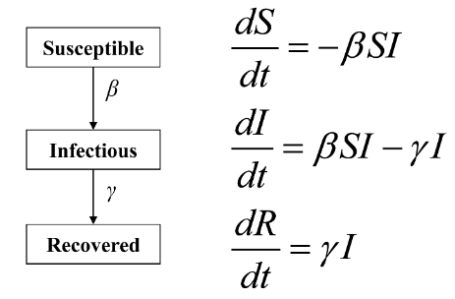

With each contact between an infectious host and a susceptible host, the susceptible hosts become infected at rate β (the transmission rate), which decreases the proportion of susceptibles in the population.

$$\frac{dS}{dt}= -βSI$$

Where *S* is the number of susceptible individuals, and *I* is the number of infected individuals.

For this model, we assume that the disease spreads rapidly enough that we can ignore the birth of new susceptible individuals. Think of seasonal flu, an outbreak of measles, or an outbreak of Ebola virus. More complicated models are used for slowly spreading diseases, such as leprosy (and allow for addition of susceptible individuals by births in the population).

*Optional self-check 3: If there are more susceptible individuals, all else being equal, how will that affect the change in numbers of susceptible individuals over time?*

The equation above accounts for the removal—via infection—of individuals from the pool of susceptible hosts. The equation below models the addition of these individuals to the infected pool as well as the loss of infected hosts at some rate, γ, by recovery (and immunity) or by death.

$$\frac{dI}{dt}= βSI- γI$$

To determine the conditions under which the infections will stop increasing, we need to solve for the equilibrium number of susceptible individuals at which $\frac{dI}{dt}=0$.

$$\frac{dI}{dt}=0 when βSI= γI$$

**Q 1.** At what value of *S* (expressed in terms of the model parameters β and γ) is the rate of change in infections equal to 0? (options on Gradescope).

This value of *S* is the **epidemic threshold**: on one side of the threshold, the disease will increase to epidemic levels, and on the other side it will decrease. Again, knowing this value allows us to determine the number or fraction of the population that we need to vaccinate to prevent epidemics (even if we do not know R0). We will investigate the behavior of this model using R code and see how the dynamics play out from different starting conditions.

The parameter γ is (1/infectious period), but β is usually estimated based on R0. The infectious period is the time interval when an infected individual can transmit the disease to another individual, and in this model is assumed to begin as soon as the individual is infected. Removed individuals can be immune or dead, and the number of these is often not plotted.

*Optional self-check 4: What happens to the rate of change in infections when the infectious period is longer, all else being equal?*

Note that S and I are easily observed with a good monitoring system, and β and γ can be estimated from the same data, or γ can be observed from the infectious period.

# Phase portraits of disease dynamics

Download the code from Canvas.

Start RStudio and open the R code. It has been mostly written for you, but later in the exercise you will copy and modify some lines of code to investigate model behavior with different initial conditions and parameters.

The R code first defines a function with the differential equations in it and specifies model parameters and initial conditions. It calls on ode from the package deSolve (which you will need to install) to solve the equations. Remember you only need to install the package once.

We put the results in a data frame called “out” that has the time intervals, the number of susceptible hosts, and the number of infected hosts at each of those times. Therefore,

plot(out[,1], out[,2])

plots the number of susceptible hosts versus time, and

lines(out[,1], out[,3])

overlays a line on the graph with the infected hosts.

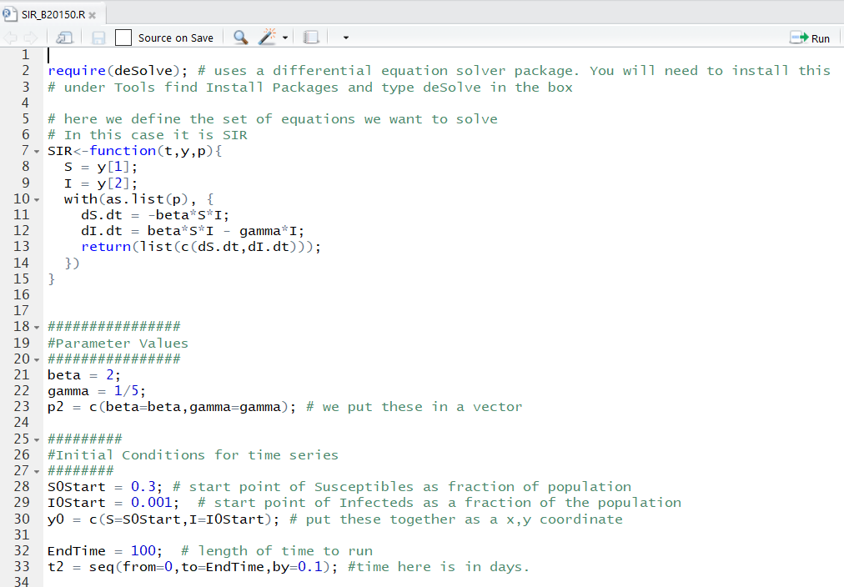

The next bit of code plots infected hosts versus susceptible hosts on a graph known as a **phase portrait**, or **phase plane** or a **state space**. Points in the space of a phase portrait represent combinations of abundances of two interacting populations, or in the case of our SIR model, of two groups within a population (infected and susceptible individuals). Realize that for many models, population abundances will change along different trajectories depending on the starting conditions. We will thus vary starting conditions as we run the SIR model to examine how initial abundances of susceptible and infected individuals influence the spread of a disease in a population.

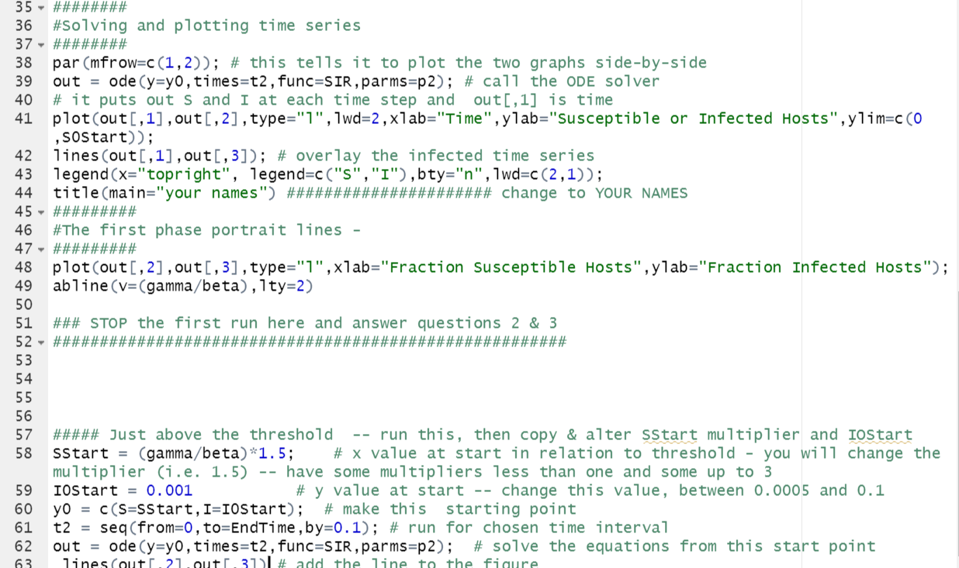

Change line 44 so you get your names as the title of the figure.

**Run lines 1-50**. You will get two plots, a time course and a phase portrait, as seen below. (If your plots look odd, expand the plot portion of the RStudio windows.)

**Q 2.** What is the vertical line on the phase portrait?

**Q 3**. Examine the graphs below. Match each point on the upper graph (time series, points A, B, and C) to the nearest corresponding point on the lower graph (phase portrait, points 1-5).

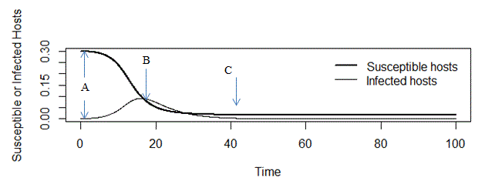

**Phase portrait**

**Time series**

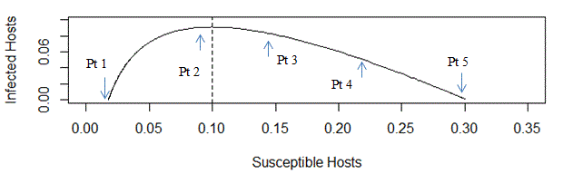

*Optional self-check 5: Although time is not explicit in the SIR phase portrait, it is present. Does it run left to right, or right to left?*

As stated earlier, the course of the outbreak will depend on the starting conditions: the fraction of the population that is susceptible (SStart) and how many infected individuals are present initially (IOStart). We’ll vary these initial conditions in the exercise below, but we will not plot the time series (upper graph) again.

We have provided the code for the first set of starting conditions in lines 57 -63 (where it says “just above the threshold”). Run these lines of code to solve the differential equations from this new starting point and plot the outcome on the phase portrait.

**Next, run the model with at least 4 additional starting points that you come up with**. Copy all the lines of code from 57 down to the end, paste them into the (upper) script window, and modify the SStart multiplier and the IOstart for each run. Note that SStart (starting number of susceptibles, expressed as a fraction of the population) has been defined relative to the gamma/beta value –you can try different values of that *multiplier*. Start some runs with the SStart multiplier >1 and some <1, but keep the multiplier less than 3. IOStart (starting number of infected individuals, expressed as a fraction of the population) should be kept <0.1.

*Optional self-check .5: Look at the code in lines 59-64, what is the multiplier for SStart?*

**Q 4.** These questions consider what is happening to the disease under these different starting conditions.

**Q 4.1** When the initial fraction of the population that is susceptible falls above the threshold, what happens to the time course of disease spread?

**Q 4.2** What happens when you start with an initial number of susceptibles that is below the threshold?

**Q 4.3** Are there any new infections at all when you start below the threshold?

**Q 4.4** Upload your graph to Gradescope. Make sure your names are on it.

**Q 4.5.** What fraction of individuals do we need to vaccinate (assuming no other source of immunity and resistance) to try to keep outbreaks of this disease from happening?

**Q 4.6** What brings the epidemic to an end?

# Measles

**Q 5.1.** Measles has an estimated R0 of 12 to 18. What proportion of the population must be vaccinated to get herd immunity if R0 is 12?

**Q 5.2** What proportion of the population must be vaccinated to get herd immunity if R0 is 18?

Examine the graph below, which depicts the fraction of the UK population vaccinated against measles between 1965 and 2010 and the number of measles cases between 1995 and 2010. Measles cases were much, much higher before 1995.

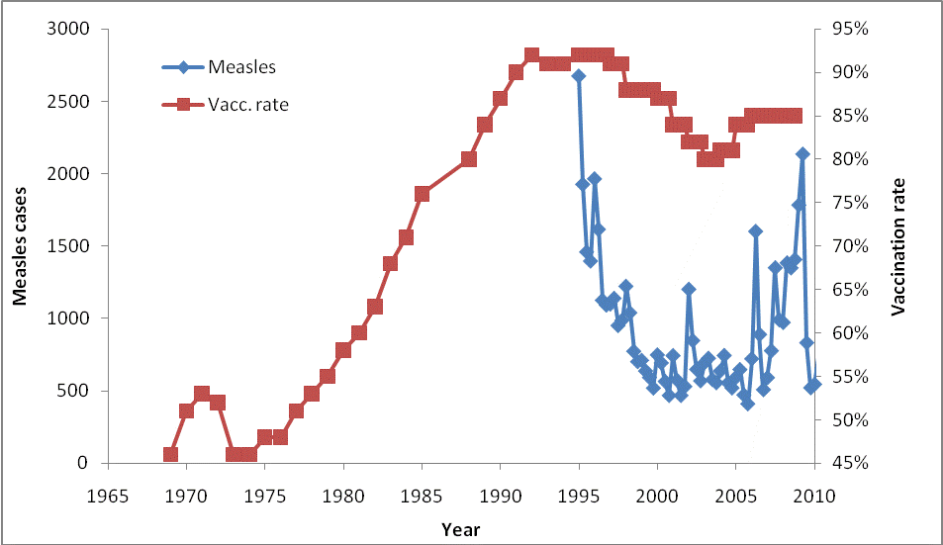

**Q 5.3.** Explain the pattern depicted in the figure in light of the answer you gave in the previous questions. Note that vaccinations occur in the first year of life, but measles is more often seen in school-age children.

# SARS COV-2

So far, we have treated the R0 as if it is a fixed entity, but it changes based on many factors, not least of which is the behavior of people, such as how many contacts they have and whether they wash hands and wear masks.

The graph below shows estimates of Rt for Wuhan, China, where the outbreak was first detected. It is called Rt because it varies with time, but is still the number of new infections per old infection, but averaged over 5 days (grey indicates 95% credible intervals). We can use the fact that γ = 1/(infectious period) and Rt = β/γ to find β. Now along with much else about this novel infection, the infectious period is not known with certainty, but most sources say 10 days for mild cases and 20 days for severe cases (but these cases are typically hospitalized) so we will use 10 days.

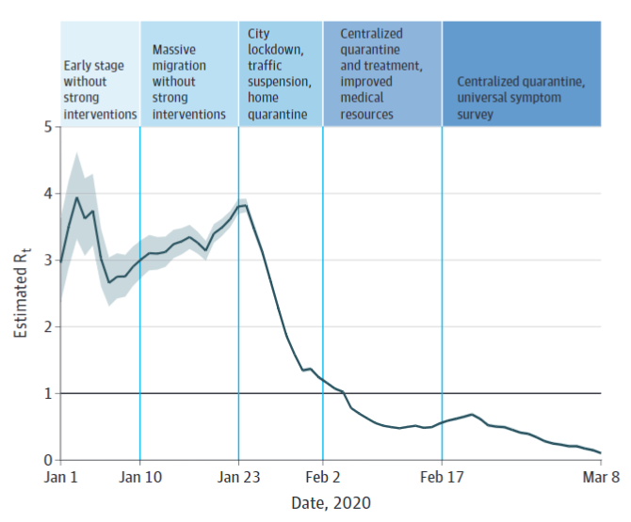Inglesby, 2020.

First for Rt at each of the stages listed in the table below, what would β (the transmission rate) be? Then we will plot and see what the epidemic threshold is and consequently what fraction of the population needs to be vaccinated to control the epidemic.

|  |  |  |
| --- | --- | --- |
|  | Rt | β |
| Early, no intervention | 3.5 | Click or tap here to enter text. |
| City lockdown, etc | 2.5 | Click or tap here to enter text. |
| Centralized quarantine, etc | 0.75 | Click or tap here to enter text. |

**Q 6.1** What are the values of β for each of the Rt values?

Change the parameters of the model to match the case for SARS CoV-2.

Find the following parameters in your code and set them to the values given below (lines 21, 22, and 28):

Beta = (value you calculated for Rt =3.5)

Gamma = 0.1

SOStart = 0.95

Run the model. You may use the same sets of initial conditions as before.

**Q 6.2** Upload your graph (PNG, BMP, GIF) to Gradescope.

**Q 6.3** What fraction of the population needs to be vaccinated to prevent an outbreak if no other intervention is taken?

## Answers to self-check questions

1. The disease will start to decrease in incidence.

2. Herd immunity threshold = 0.83

3. The pool of susceptibles will decrease faster (by becoming infected), if there are more initially.

4. If the infectious period is longer, the infections will increase more rapidly (γ will be smaller, so individuals exit the infected class more slowly).

5. Time runs from right to left in this phase portrait, the opposite of what is usual in graphs! Susceptibles will only decrease in abundance.

6. The first SStart multiplier in this block is 1.5.

## References cited

Fine, Paul, Ken Eames, and David L. Heymann. 2011. “Herd Immunity”: A Rough Guide. Clin Infect Dis. (2011) 52 (7): 911-916. doi:10.1093/cid/cir007

Inglesby TV. Public Health Measures and the Reproduction Number of SARS-CoV-2. JAMA. 2020;323(21):2186–2187. doi:10.1001/jama.2020.7878